

Bridgewater–on–Loddon
Primary School
2027 Information Booklet

Principal: Mr. Matthew Lehane

Address: 34 Eldon Street Bridgewater VIC Phone: (03) 5437 3081

Email: bridgewater.ps@education.vic.gov.au
Web: www.bwaterps.vic.edu.au

Contents

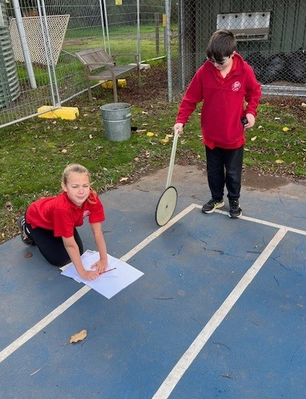
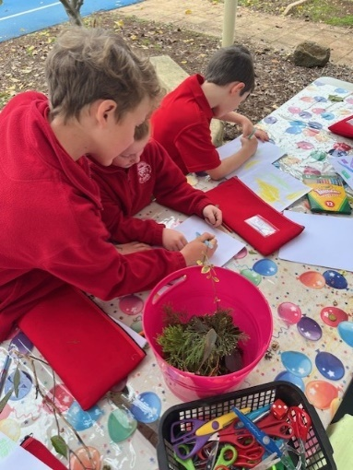
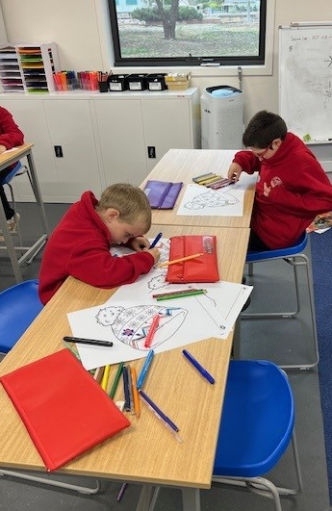

Letter to Parents ................................................................................ 2
Bridgewater Primary School Vision Statement & Values ................ 3

2027 Staff ............................................................................................. 4
2027 Term Dates ................................................................................. 5
Parent Involvement ............................................................................6
School Procedures ............................................................................. 7
Student Welfare .................................................................................. 9
Student Learning ................................................................................ 11
Student Safety & Health .................................................................... 14

Letter to Parents

Dear Parents and Guardians,

Welcome to Bridgewater-on-Loddon Primary School!

We are proud to be a small rural school with a big heart—where every child is known, cared for, and supported to thrive. At Bridgewater-on-Loddon Primary School, we are committed to providing a comprehensive and future-focused education grounded in evidence-based practice.

Our teaching and learning programs are continually reviewed and refined to ensure they reflect the most effective approaches. In recent years, we have been implementing the Science of Reading through our InitialLit Literacy program. This structured and systematic approach to teaching reading ensures that all students build strong foundational skills in literacy.

We believe that every student learns differently, and we honour this by developing an Individual Education Plan (IEP) for every child. This allows us to tailor learning goals, provide targeted support, and celebrate each student’s progress in a meaningful way.

Our unique rural setting is something we value deeply. We make the most of our environment by engaging in hands-on, place-based learning experiences such as the River Detectives program, which connects students with their local landscape and builds a strong sense of environmental responsibility.

At the heart of everything we do are our core values: Respect, Relationships and Excellence. These values guide our actions and decisions, creating a positive and inclusive school culture.

We recognise the importance of a strong family–school partnership. Your involvement and communication are vital in helping us provide the best possible education for your child. We value your input—after all, a concern of yours is a concern of ours.

We look forward to welcoming your family to our school community and sharing in the journey of learning and growth together.

Warm regards,
Matthew Lehane
Principal
Bridgewater-on-Loddon Primary School


BRIDGEWATER PRIMARY SCHOOL VISION STATEMENT & VALUES

RESPECT, EXCELLENCE & RELATIONSHIPS
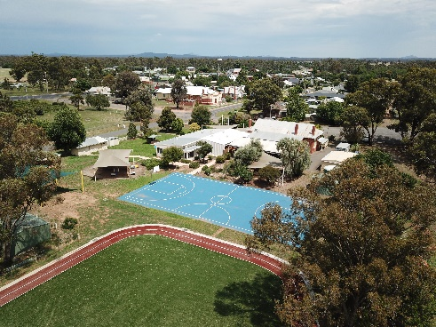
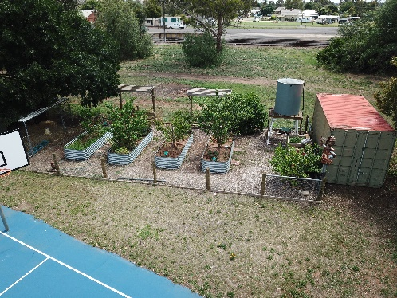
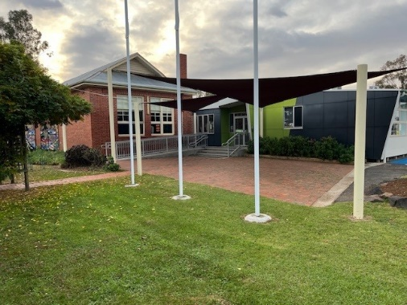

Growing and caring for each other!

SCHOOL VISION:

To provide a respectful and caring environment that aims for excellence in learning and nurtures positive and productive relationships for all students, teachers and parents.

SCHOOL VALUES:

We are Respectful
Respect community, property and the environment; value diversity; behave inclusively; speak and act appropriately; have zero tolerance for bullying and abuse (see Child Safe Policy)

We Aim for Excellence
Set high expectations; are accountable; are student focused; promote self-management; have a ‘Have-a-go’ and persist; do our best and aim high; build quality teaching & learning; provide an engaging curriculum; value constructive feedback and diversity in thinking; celebrate success; encourage calculated risk taking; set goals and are achievement driven.

We Value Relationships
Build positive relationships, promote community involvement, nurture others, develop our social skills, work in teams, foster resilience, are mindful, behave considerately, do the ‘right’ thing, are honest and respectful in our interactions, keep each other safe.

2027 Staff

Mr. Matthew Lehane Principal
Mr. Joanne Egan Business Manager
Miss Emalee Deane Junior Classroom Teacher
Mrs Madeline Punton Senior Classroom Teacher
Ms Bronwyn Coffey Mental Health Wellbeing Leader
Mrs. Megan Lynch Student Well-Being Chaplain
Mrs. Leanne Scholes Librarian
Mrs. Karen Rees Mobile Art Resource Centre (MARC) Teacher
Miss Jaquelin McCormack Classroom Support
Miss Maddi Hart Classroom Support

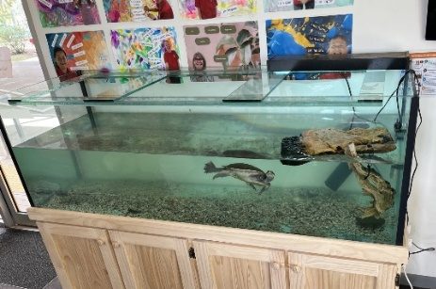

Harry

Our school pet is a murray river turtle named Harry.

Harry was donated to the school by our MARC teacher Mrs. Gentry. Harry is about 17 years old.

2027 Term Dates

 | Start Date | Finish Date
Term 1 | 27th January (Staff)  28th January (Students) | 2nd April
Term 2 | 20th April | 26th June
Term 3 | 13th July | 18th September
Term 4 | 5th October | 18th December

Parent Involvement

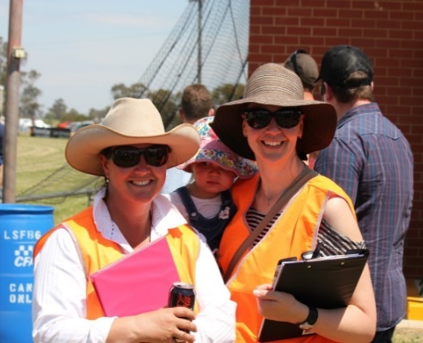
We enjoy a friendly, open atmosphere. Parents are welcome.
We want and need you to be active in your child's learning.
The following are some ways you can help: -
- Parents' Club
- School Council
- Participating in Working Bees
- Hearing children read
- Classroom helpers (speak to your child’s teacher)
- Camps and excursions volunteer
- Swimming/gymnastics program volunteer
- General class activities as they arise

School Council
Our School Council is an important body and is involved in making decisions on educational policy, management, finance and environment issues. Our School Council consists of 6 members: - 4 parents and 3 staff members. They meet regularly on a monthly basis (twice a term on Wednesdays at 4:00 p.m.). Elections are held every year in February/March. School Council also has a number of sub-committees: - Management, Policy Development and special project groups. You can support our community in any number of ways.

Our current School Council members are:

- Matthew Lehane (Principal & Executive Officer)
- Kate Chandler (President)
- Karryn Bennie (Vice President)
- Jemma Wybar (Finance Committee Convenor)
- Dallas Goodman
- Clare Nalder
- Madeline Punton (Staff)
- Emalee Deane (Staff & Minute Taker)
- Heidi Ferguson (Community Member)

School Procedures

School Timetable

9.00 – 11.00am Learning Block 1(Literacy Based)
11.00 – 11.45am Morning Recess
11.45 – 1.45pm Learning Block 2 (Numeracy)
1:45 – 2.15pm Lunch & Play
2:15 – 2:30pm School Wide Student Jobs eg. Feeding chickens
2.30 - 3:30pm Learning Block 3 (Specialist Subjects & Humanities)
* Children should be at school on time each day and NOT earlier than 8.30 am.
** Dismissal on the last day of Terms 1, 2 & 3 is at 2.30 pm.
*** Dismissal on the last day of Term 4 is at 1:30pm.

School Crossing
A traffic supervisor is on duty before and after school on the main highway between 8.20 am and 9.05am each morning and 3.20pm - 3.50pm each afternoon.
Please help to teach your child to use the crossing correctly.

Attendance
Regular and punctual attendance is essential. If your child is absent, please provide a note or verbal explanation. A note can be generated on our uEducateUs website/App, or you can also email our Business Manager, Joanne Egan joanne.egan@education.vic.gov.au.

Accident, Illness & Emergency Contact
If your child is injured or ill, you will be contacted and asked to collect your child. If we are unable to contact you, then we will contact the person/s you have nominated as an emergency contact.
It is extremely important that phone number information available to us is kept up to date.

Student Contributions
The Bridgewater Primary School seeks to provide a variety of programs which will interest all students, the items below have all been included in our 2027 School Budget.
Please note that we do not charge ANY VOLUNTARY FEES.

We make a very concerted effort to keep our school charges to a minimum.
It is imperative that all parents pay school contributions as it funds camps &excursion, cluster days and library (MARC Van).

Camps, Sports and Excursions Funding (CSEF)
To be eligible, parents must hold a current Commonwealth Health Care Card or pension card. It is imperative that the school sights the validity period of the Health Care Card. All queries by parents should be directed to the school.

Essential Learning Items
Our school aims to provide everything your child NEEDS for their learning. Below are the items families are expected to provide:
- A School Bag
- Lunch box
- You may wish to supply additional colouring pencils and texta’s however the school provides pencils cases with all required basic stationary.

Books And Supplies
The school purchases all necessary stationery, texts and other consumable materials. If school supplied items are lost or wilfully damaged, parents will be asked to replace them at their own expense. A waterproof reader bag is provided by the school when your child begins Prep.

School Lunches
The school aims to provide lunches to students once a week. These lunches may include fresh sandwiches, soup. toasties, sausages, hot dogs or pies depending on the time of year. At times such as during our swimming programs these regular lunches may not happen due to the interrupted timetable.

From time-to-time Parents Club provide hot lunches. When operating, order forms are attached to the newsletter each week. This is a fundraising activity for the cost of the Camp bus.

Lunch Orders
Lunch orders can be purchased every Friday. Orders are to be sent to the school office on Thursday before 10am for Friday lunch. Bridgewater Bakery deliver them to the school at the start of Lunch on Friday.

Newsletters
The school newsletter is published digitally every fortnight on Friday afternoon on our Facebook page and on our Website. Contributions need to be submitted to the office by 9am Friday. Important school information is published in the newsletter. It is important that parents read the newsletter. An archive of newsletters is available to download from our school website: www.bwaterps.vic.gov.au

Sending Money To School
We encourage parents to pay their school fees via EFTPOS. The school’s bank details are on the newsletter each week. All cash payments (lunches, stalls, etc) need to be brought to school using the school collection envelope. Complete the child's name, amount & purpose. Wherever possible, please provide correct amounts. Envelopes must be placed in the mailbox located at the office. Additional envelopes are available from reception.

Media Permission Forms
Each parent will be asked to sign a media permission form to allow children to be photographed at school, on excursions and camps. This will also enable your child to be included on the school web site. Photos used by the news media or on the internet only include student’s first names. These photos may be used in the school magazine.

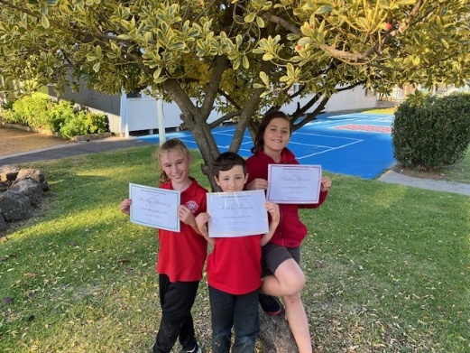
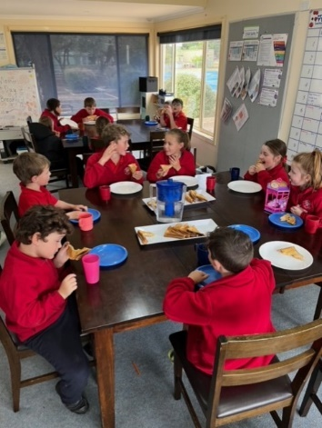
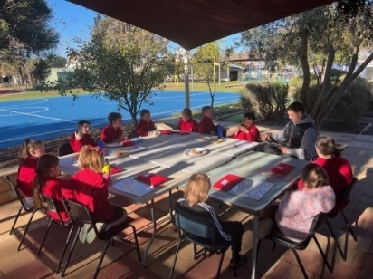

Student Welfare

Student Engagement Policy
Our Student Engagement Policy is based on the principles of fairness and honesty. Staff undertake to ensure that the guidelines are understood by all and are administered in a warm, caring environment which creates and maintains respect for the rights of others.
A copy of the policy will be sent home.

We have clearly stated rules and consequences. Behaviour is monitored rigorously. Students who abuse other’s rights will be placed on a Behaviour Management Plan, which is negotiated with the student and parents. This sets a framework for the child to improve their behaviour.

The school has a zero tolerance on bullying. We run numerous programs to develop understandings and strategies for resilience:
- Healthy Relationships
- Restorative Practice
- Puberty Program (IDHS)

Wellbeing Dog
We are fortunate to have our very own wellbeing dog, Poppie. Poppie has undergone extensive training through the Dogs Connect Program specifically for school settings. At the moment she attends school 2 days a week.

Chaplaincy/Welfare Program
Our Chaplain is available one day a week to support the wellbeing of students and families. The Chaplain works across the school in a variety of ways; including one-on-one sessions, small group activities, and classroom support. This Student Wellbeing Chaplain provides a safe, caring presence in the school by offering social, emotional, and practical support to help students thrive. The Chaplain also supports parents/caregivers by helping to connect and refer families to services and supports they might need. To access the Chaplaincy service a consent form is required to be completed. Students and Parents can access the Student Wellbeing Chaplain during school hours and is also contactable via the school phone number or email.

The Mental Health and Wellbeing Leader
The Mental Health and Wellbeing Leaders (MHWLs) in schools play a role in fostering a supportive environment for students and staff. They are responsible for building the capacity of the school community to identify and support mental health needs, providing training and resources, and ensuring access to appropriate support services. They also focus on preventative strategies and promoting a positive school culture.

Here are some of their responsibilities:
- Building Capacity:
MHWLs train and support staff, particularly classroom teachers, to recognize and address mental health concerns in students.
- Referral Pathways:
They establish clear pathways for students who need additional support, connecting them with school-based resources and community services.
- Whole-School Approaches:
MHWLs implement and promote school-wide mental health and wellbeing initiatives, working with various stakeholders, including school leadership and other support staff.

- Collaboration:
They collaborate with regional education departments, school wellbeing teams, and other health professionals to coordinate appropriate mental health support.
- Promoting Mental Health:
MHWLs actively promote mental health and wellbeing within the school, raising awareness and reducing stigma.
- Data and Evaluation:
They may be involved in collecting and analysing data related to student mental health, helping to identify areas for improvement.
- Policy and Practice:
MHWLs contribute to the development of policies and practices that support student mental health.
Outside Agencies
The school also provides access to:
- Speech Therapist
- Educational Psychologist
- Social worker – department and IDHS
- State Schools Relief (school uniforms)
- Other outside agencies as needed

First Year of Schooling
Beginning school is a major event in your child’s life. To assist in a smooth transition, you can:
- Talk to your child about school where they will meet new friends, play games, sing, and make things.
- Make their transition to school happy and safe.
- Never use school as a threat.
- Take your child to school and show them around before they actually begin.
- Insist on them using the crossing when necessary.
- Buy clothes that are easy to manage. School uniforms provide a durable non-competitive form of clothing that is preferred wear.
- Give your child simple duties around the house to foster their confidence in the performance of simple tasks.
- Encourage your child by admiring their work when it is brought home.
- Give paintings and other schoolwork a place of honour for a few days at least.
- All possessions must be clearly labelled.

Be Ready for School
Try to ensure your child:
- Knows their name and address well enough to repeat when necessary.
- Knows the safest way to and from school.
- Knows road rules - especially when using the school crossing.
- Always has a handkerchief or tissues and knows how to use them correctly.
- Knows how to use and flush the toilet without assistance.
- Knows that hands should be washed after visiting the toilet.
- Knows how to tie shoelaces.
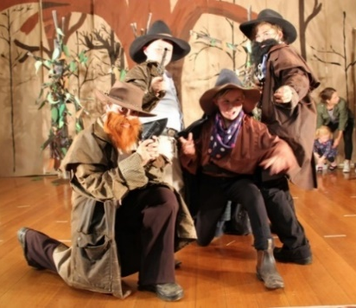
- Puts away playthings and materials after using them.
- Takes off and puts on outer clothing (jumpers, coats) without assistance.
- Knows never to bring to school any article or item that could cause an accident, or anything of a personal nature.
- Recognises their own name when written.

Student Learning

Achievements
These can be varied – academic, sporting, behaviour, individual or team achievements.

Work Samples
Work samples vary depending on the grade. They are examples of the work your child is doing in class.

School Reports
At the end of Term 2 and Term 4, you will receive a School Report documenting your child’s progress.

Victorian Curriculum 2.0 and Victorian Teaching & Learning Model 2.0

The Victorian Curriculum 2.0 is the updated Foundation to Year 10 curriculum designed to ensure every student develops the essential knowledge and skills they need for success in school and beyond. It features clearer content, refined achievement standards, and a greater focus on deep learning, critical thinking, and contemporary capabilities. The revised structure now includes six strands across learning areas such as Mathematics and English, promoting stronger curriculum alignment and progression.

The updated Victorian Teaching and Learning Model (VTLM) 2.0 supports schools with a renewed focus on high-impact, evidence-based teaching. It provides updated pedagogical guidance, refined practice principles, and tools to support professional collaboration and improve student outcomes.

At Bridgewater Primary School, we are committed to successfully implementing these updates. Our leadership team and teaching staff actively engage with professional networks and draw on current educational expertise to ensure high-quality curriculum delivery. Our long-standing commitment to systematic phonics instruction—now embedded for over five years—places us ahead of many schools in preparing students with strong foundational literacy skills. This early work positions us well to meet the demands of the new curriculum and continue delivering excellent outcomes for every learner.

Digital Technology in The Classroom
Bridgewater-on-Loddon Primary School introduces computers in the classroom in the Prep year. We then build upon the student’s experiences and knowledge over the proceeding years to ensure that all have a sound understanding. A policy of continually upgrading hardware and software ensures that at all class levels a multi-media computer is available. The school is well resourced with desktop computers, netbooks, interactive whiteboards, digital cameras, a video camera, scanner, and a multimedia projector. Children participate in the following structured activities: - word processing, math drills, spreadsheets and database activities, using the Internet and multi-media software packages for research and in using graphics packages for specific presentation briefs. Some recent initiatives have been wikis, blogging, podcasting etc.

Language Other Than English
In 2025 students commenced learning AUSLAN (Australian Sign Language) as their additional language. Sessions take place on a Friday, with Miss Deane teaching the F-2's and Mr. Lehane teaching the 3-6's.
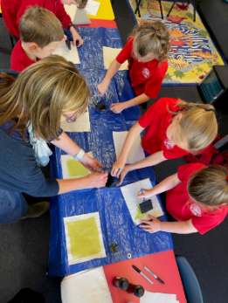
M.A.R.C. (Mobile Area Resource Centre)
This is a fortnightly Library Program that allows students to borrow books and experience structured library lessons.

Scholastic Book Club
Information and order forms will periodically be attached to the newsletter. Orders and money need to be returned to the Office by the due date.

Parent/Teacher Interviews and Reports
Reports and interviews are conducted formally with parents at the end of Term 2. You will be notified in advance of these dates and times. Reports are also sent home at the end of Term 4. If at any time you have a concern that you would like to discuss with the Principal or your child's teacher, please make an appointment either by note or telephone
River Detectives and Outdoor Classroom Program

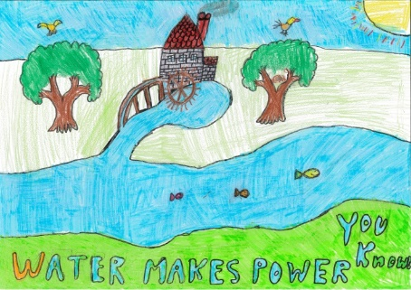
River Detectives is an exciting education initiative of Catchment Management Authorities inspiring students to understand, appreciate and care for our local river through engaging, cross-curricular, citizen-science activities.
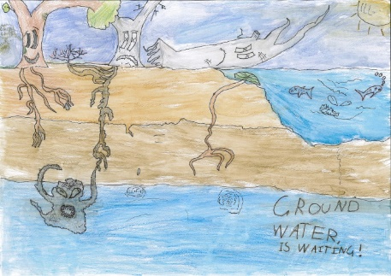

Individual Learning Plans (I.L.Ps)
The Victorian Department of Education mandates that Individual Learning Plans (I.L. Ps) are developed for all students who have a Koorie background, Disability Inclusion Funding or are living in Out of Home Care however, due to our small class sizes and focus on targeted teaching provide all students with an ILP.

Health & Physical Education
Each child brings a diverse range of experiences, skills and enthusiasm for physical activities to school. The H&PE program provides sequential activities, which
develop & build upon previously acquired levels of achievement
& attitudes. The program provides the opportunity for teaching
in a way that reflects the skills, knowledge & attitudes needed to
facilitate a life-long involvement in physical activity.

The activities provide a balance between: -
- enjoyable work and free play.
- co-operation and competition; and
- group and individual play.

Gymnastic Program
Each year, children attend the gym in Bendigo for 4 sessions. Students are required to wear the sports uniform (no jewellery). This is held in conjunction with the Winter Swimming Program at an indoor pool.

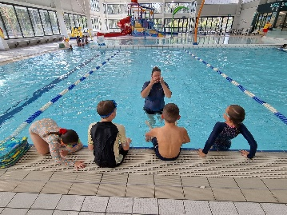
Swimming Program
The swimming program is conducted over 5 sessions at the Eaglehawk Peter Krenz Leisure Centre in the heated pool, in conjunction with table tennis or badminton. An open water swimming program is also conducted by Lifesaver instructors at the river in December, providing students with lifesaving skills in and around waterways.

Sports Days
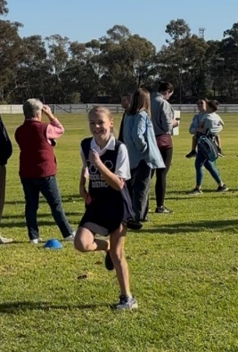
Cross Country, Athletics days and Spring Sports days are run as part of a local cluster, consisting of Bridgewater, Inglewood, St. Mary’s, Marong, Lockwood and Lockwood South Primary Schools. The sports uniform must be worn on sports days, gym & other sports events.

- Red shorts
- White t-shirt
- Sports socks & appropriate footwear
- Hat or Cap
- Sunscreen

Sporting Schools
At times, Bridgewater PS runs Sporting Schools programs which is generally run during school. We provide free, physical activities for students. Students participate in multi-skills sessions and sports such as tennis, basketball, martial arts, football, lawn bowling etc. These sessions are delivered by experienced experts e.g., Bendigo Braves & martial arts instructors. The goal of these activities are to encourage fitness and to fight the growing obesity concerns experienced in the broader community.

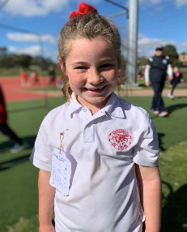
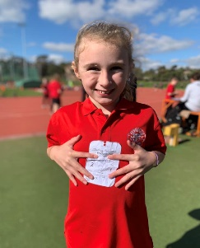
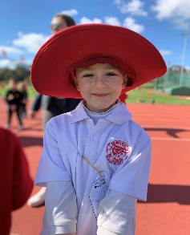
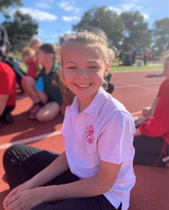

Excursions
Ample notification of excursions is given. Permission notes are generated through uEducateUs platform and must be given by the parent or guardian, or the child will not be able to attend. At times parents are invited to attend excursions to assist with supervision. If you are interested in helping in this way, in order to be considered parents must hold a Working with Children’s Card. please indicate your interest when the opportunity arises. Students must be in uniform when attending excursions.

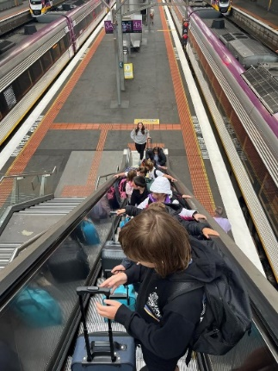
Camps
Each year students get the opportunity to attend camp which usually comprises of 2 – 3 nights away. The school alternates between urban, beach and adventure camps and try to accommodate all year levels. Somers Camp is offered every 2 years to the senior school levels, only a few placements are offered, student get to integrate with other schools on this camp.
Our camps have been open to all students from Foundation to Grade 6 however, this is currently under review and the school is exploring the possibility of doing camps with other schools.
Student Safety & Health

Medication
Many children attending school need medication to control illnesses either on a long-term or a short-term basis.
All medication brought into the school must be shown to the classroom teacher or Principal and to be accompanied with written instructions so that medication can be administered.
Please do not send children to school if they are seriously ill.

Head Lice
Periodically, there are outbreaks of Head Lice. Please inform the school if your child has needed treatment. Trained, volunteer parents check student hair regularly. Each student receives a letter informing them of the outcome. Information regarding treatment is available at the school. A permission note must be signed. This is sent home at the beginning of the year.

School Immunisation Schedule & Certificates
Prior to school entry - Triple Antigen 5 (Infamox) & Sabin 4
Before your child can be admitted to Primary School this certificate must be obtained from the either the ACIR (Australian Childhood Immunisation Register) or from your local council immunisation service. It confirms your child has been immunised against Diphtheria, Tetanus, Polio, Measles and Mumps.

School Medical Examinations
School Nursing Staff conduct health examinations of school children in Preparatory Year. Prior to the health examination a confidential medical card has to be completed by the parent/guardian.

SunSmart
From September through to April a “No hat, no play” policy exists in the school. Each student must wear a broad brimmed school hat if playing outside. If a student does not have a hat, he/she must play in the shade. Sunscreen is available in each classroom.

Bicycles/Helmets
The school has bicycle racks in the school grounds. It is State Law that cyclists and scooter users wear a helmet whilst cycling or scootering. Please ensure that the child's helmet is clearly named and suitable for them to wear.

It should be noted that the Road Traffic Authority recommends that children under the age of 9 years should not be allowed to ride a bicycle on the roads alone. Children under 12 years of age are permitted to ride their bikes on the footpath.

There will be no riding or scooting in the school grounds or on the footpath at the front of the school.

School Uniform

The School Council has endorsed the school uniform as listed below. All children are expected to wear uniform or be in school colours. (Red, Black, White, or Grey).

 | Boys | Girls
Winter | Black track pants  Red Bridgewater polo shirt  Red Bridgewater polar fleece jumper or jacket | Black track pants  Red Bridgewater polo shirt  Red Bridgewater polar fleece jumper or jacket
Summer | Red Bridgewater polo shirt  Black Shorts | Red & White checked dress  Red Bridgewater polo shirt  Black shorts
Red wide brimmed hat.
Red Polo Shirts are accepted.
Suitable Footwear should be worn at all times. For example well-fitted, closed toe shoes which are comfortable and supportive when running and playing.

** NO MAKE UP, JEWELLERY, CAPS OR TANK TOPS (Singlets).

School Uniform can be ordered directly through the school or on the Bridgewater Primary School portal on Hip Pocket. (See below) otherwise the link for this portal can be found on our website.

https://goldensquare.hippocketworkwear.com.au/shop-by-customer/bridgewater-primary-school/

Secondhand Uniform
The Parents Club has second-hand uniforms for sale, all items are $2.00 a piece. If interested, please inquire at reception.

Naming Personal Property
Please label clearly and permanently all items of clothing and personal property brought to the school. All named property will be returned to the student. A lost property box is maintained until the end of each term. Any unclaimed items are washed and donated to the Parents Club second-hand uniform cupboard.

